Task on S3
1: Create an S3 bucket and upload some objects to S3.
1 Open AWS Console → S3.
2 Click Create bucket.
3 Enter the Bucket name.
4 Select the required AWS Region.
5 Keep the default settings.
6 Click Create bucket.
7 Open the newly created bucket.
8 Click Upload.
9 Add the required files/objects.
10 Click Upload.
11 Verify the objects under the Objects tab.

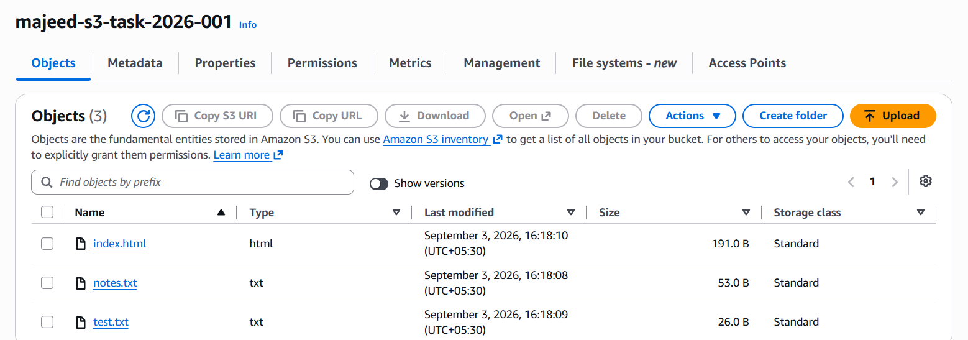
2: Deploy a static website in the S3 bucket.
Open the S3 bucket.
Go to Properties.
Enable Static website hosting.
Select Host a static website.
Enter index.html as the Index document.
Save the changes.
Disable Block all public access for the bucket.
Add a bucket policy allowing public s3:GetObject.
Open the Bucket website endpoint.
Verify that the index.html webpage is displayed.
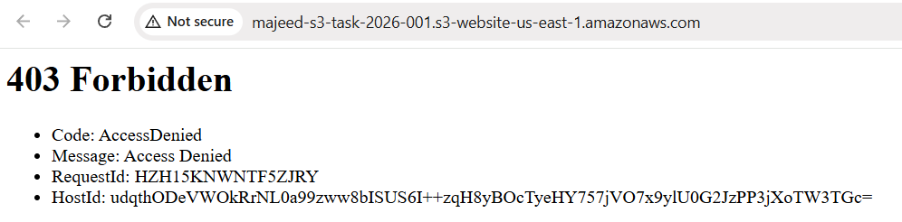
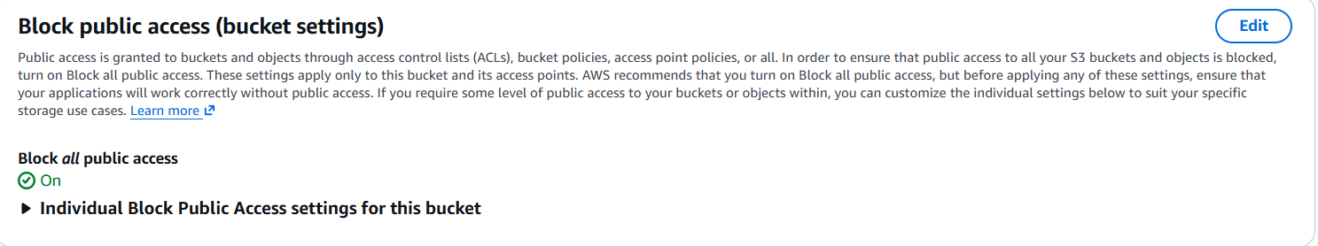
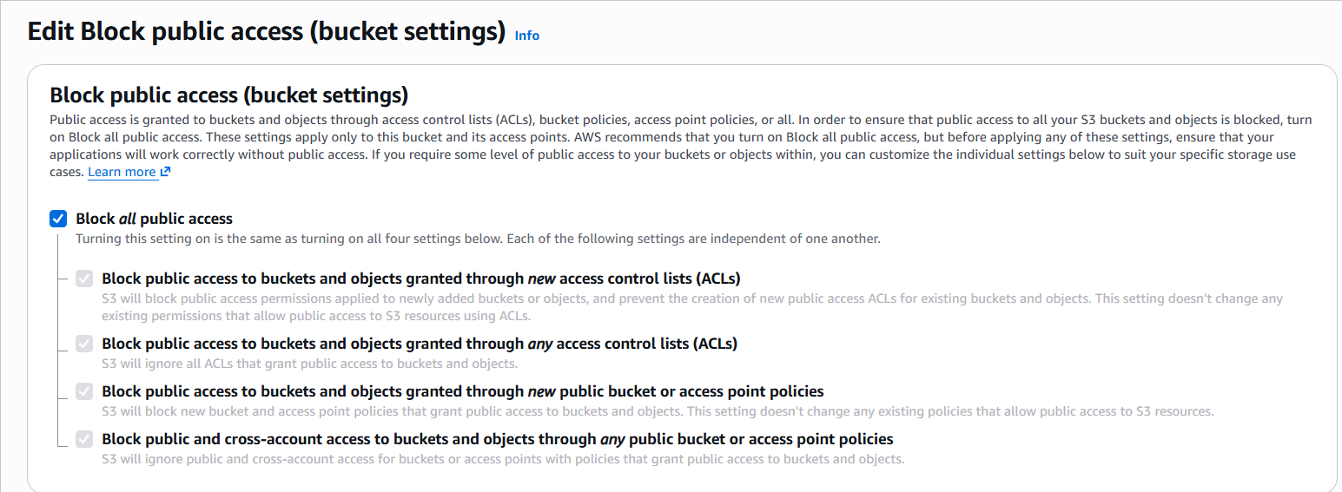
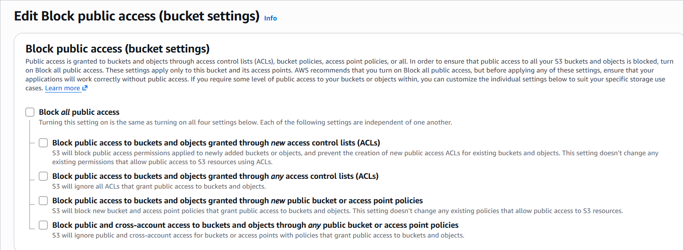
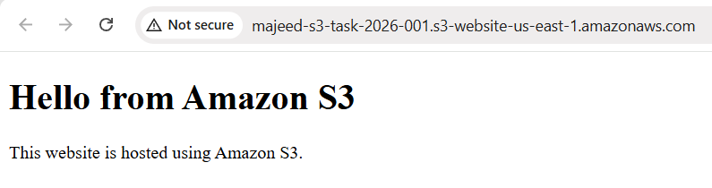
3: Enable cross-region replication on S3 buckets.
Goal
We currently have:
Source bucket
majeed-s3-task-2026-001
Region: us-east-1
We'll create:
Destination bucket
majeed-s3-task-2026-replica
Region: ap-south-1 (Mumbai)
Then we'll configure:
us-east-1 → ap-south-1
- Step 2 — Verify destination bucket
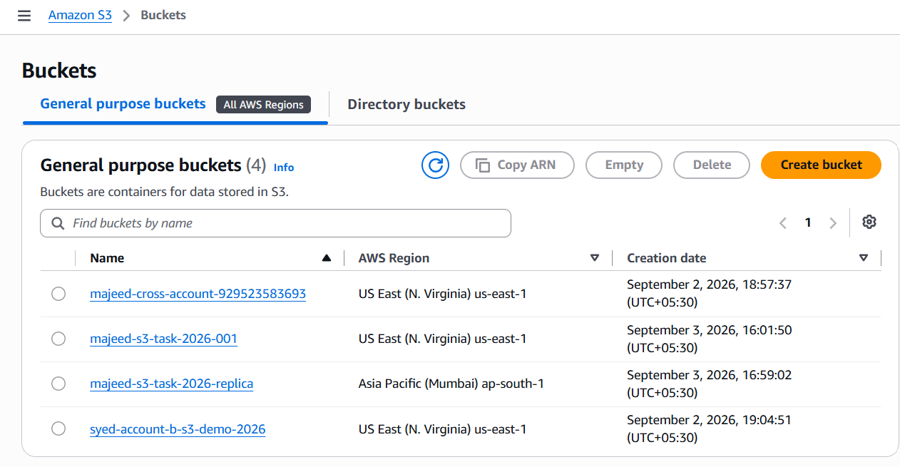
Create a second S3 bucket in another AWS Region.
Enable versioning on the destination bucket.
Open the source bucket.
Go to Management → Replication rules.
Create a new replication rule.
Select Apply to all objects in the bucket.
Select the destination bucket in another Region.
Select Create new role for IAM.
Save the replication rule.
Choose to replicate existing objects using S3 Batch Operations.
Select Automatically run the job when it's ready.
Verify the Batch Operations job shows Completed, 100%, 0 failed.
Check the destination bucket for the replicated objects.
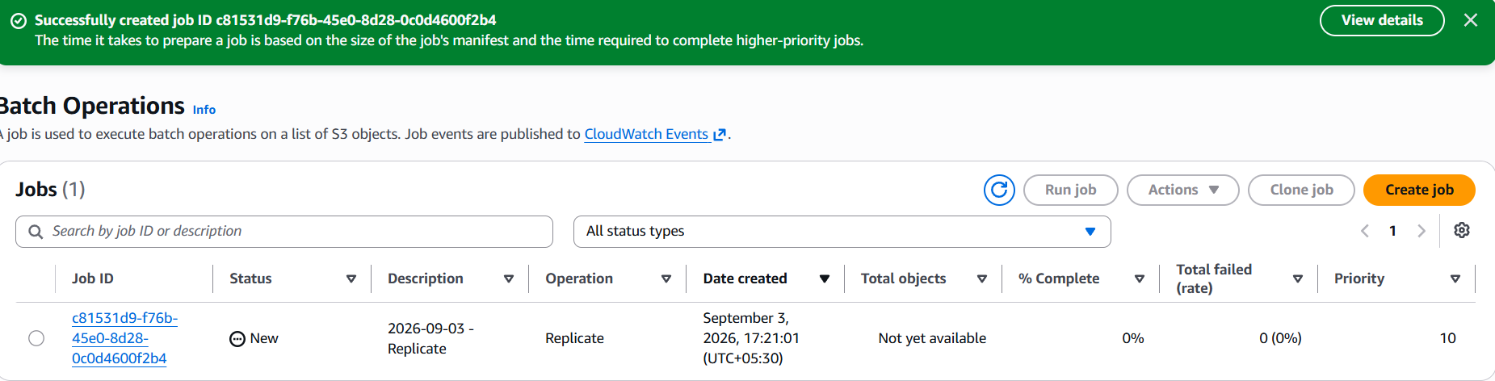
Ctrl+R
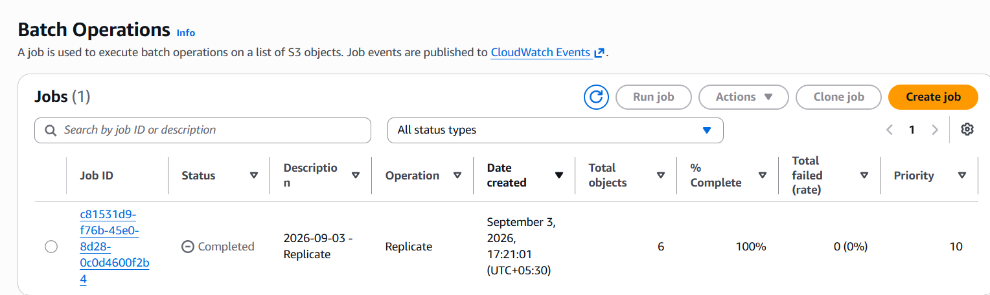

go to:
S3 → Buckets → majeed-s3-task-2026-replica → Objects
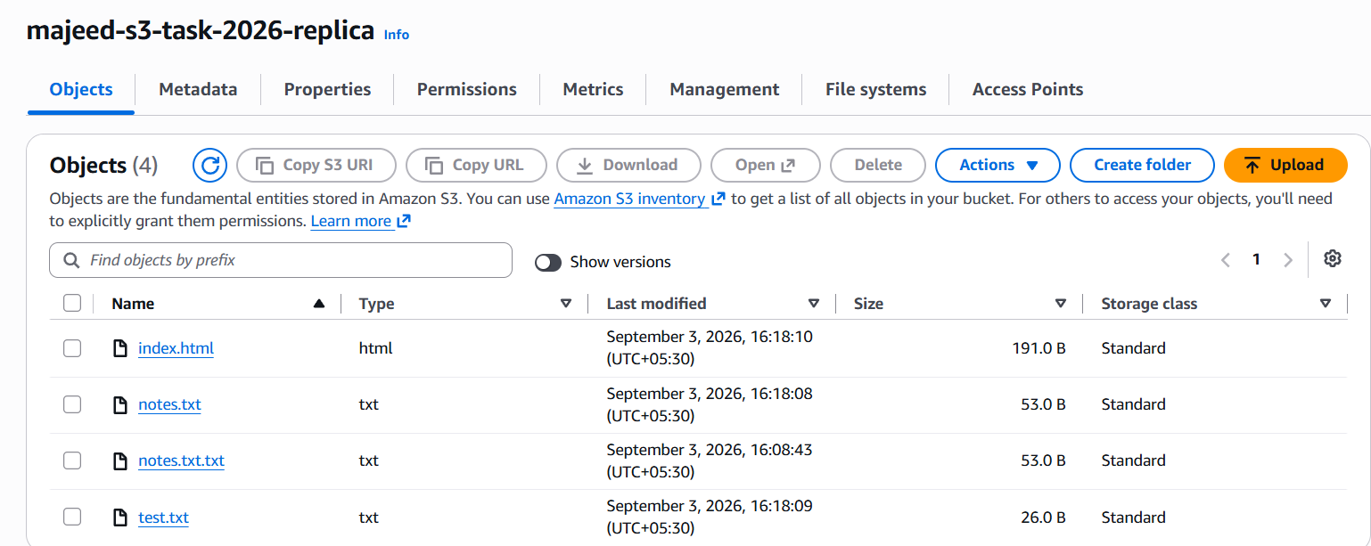
4: Configure a bucket policy so only the admin user can see the objects of the S3 bucket.
- Open Amazon S3.
- Open the source bucket: majeed-s3-task-2026-001.
- Go to Permissions.
- Scroll to Bucket policy.
- Click Edit.
- Get the IAM User ARN of DevopsAdmin.
- Add a bucket policy allowing DevopsAdmin:
  - s3:ListBucket
  - s3:GetObject
- Save the bucket policy.
- Verify the message “Successfully edited bucket policy.”
- Confirm the policy appears under Bucket policy.
Result: Only DevopsAdmin is granted access by this bucket policy to list and read the bucket objects

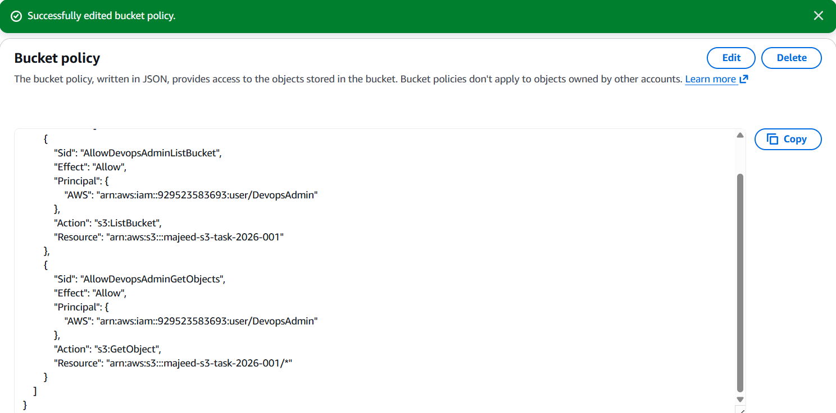

5: Set up lifecycle policies to automatically transition or delete objects based on specific criteria.
We'll create a lifecycle rule that transitions objects to S3 Standard-IA after 30 days and deletes them after 90 days.
Step 1 — Open Lifecycle rules
- Open S3.
- Open your bucket:
majeed-s3-task-2026-001
- Click Management.
- Find Lifecycle rules.
- Click Create lifecycle rule.
Step 2 — Rule name
Enter:
s3-lifecycle-rule
Step 3 — Rule scope
Select:
Apply to all objects in the bucket
If AWS asks you to confirm, check the confirmation box.
Step 4 — Lifecycle rule actions
Select:
☑ Transition current versions of objects between storage classes
Then choose:
S3 Standard-IA
Set:
Days after object creation: 30
Then select:
☑ Expire current versions of objects
Set:
Days after object creation: 90
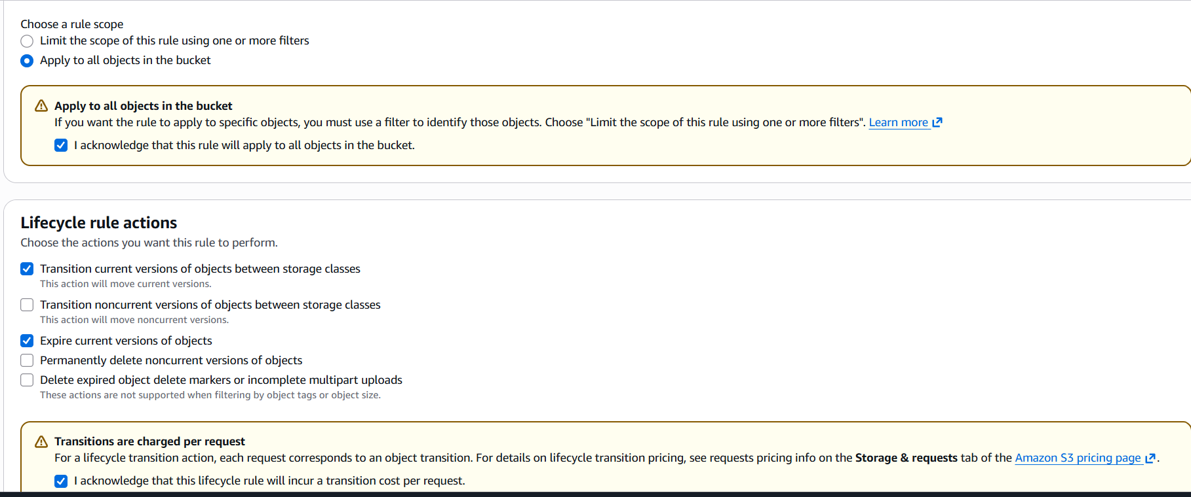
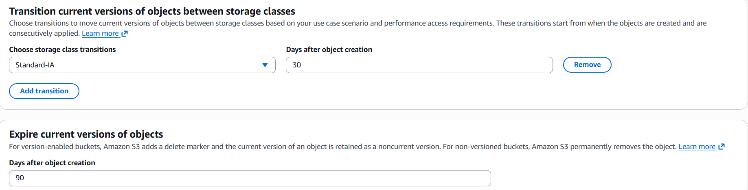
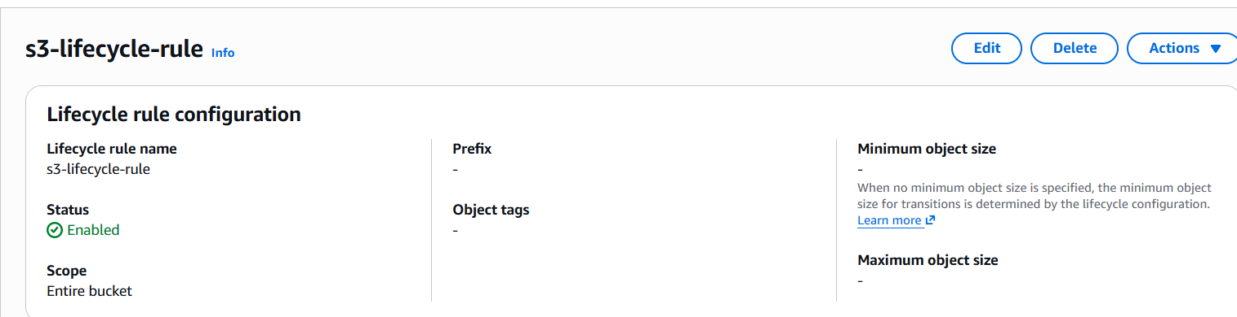
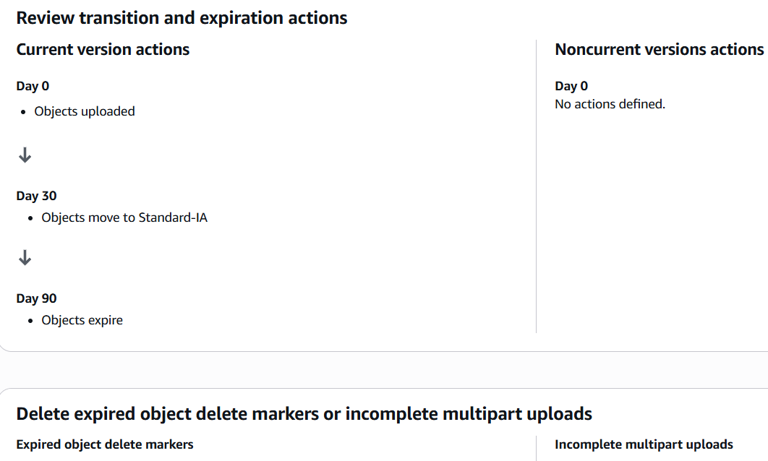
6: Push some objects to S3 using the AWS CLI.
Open Git Bash.
Create test files.
Use aws s3 cp to upload files to the S3 bucket.
Run aws s3 ls to verify the objects.
Confirm the uploaded objects are listed in the bucket.
AWS officially uses aws s3 cp for uploading local files to S3
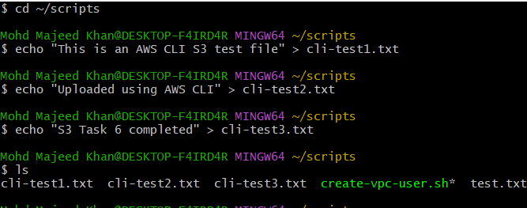
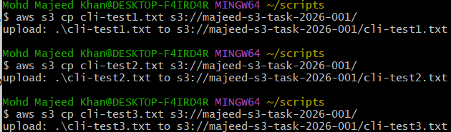
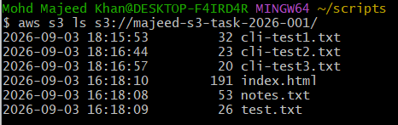

7: Write a Bash script to create an S3 bucket.
- Create a Bash script using vi.
- Define the S3 bucket name and AWS Region.
- Use aws s3api create-bucket to create the bucket.
- Add an if condition to check whether the bucket was created successfully.
- Save the script and make it executable using chmod +x.
- Run the script using ./create-s3-bucket.sh.
- Verify the bucket using aws s3 ls.
- Task 7: ✅ Completed
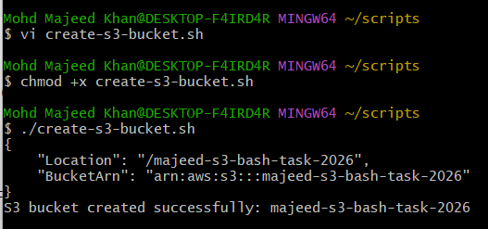
8: Upload a 1 GB file to S3 using the CLI.
1. Created a 1 GB test file:
dd if=/dev/zero of=1GB-test-file.bin bs=1M count=1024
2. Uploaded the file:
aws s3 cp 1GB-test-file.bin s3://majeed-s3-task-2026-001/
3. Verified the object:
aws s3api head-object \
--bucket majeed-s3-task-2026-001 \
--key 1GB-test-file.bin
4. Verification:
ContentLength: 1073741824 bytes (1 GiB)
ServerSideEncryption: AES256
ReplicationStatus: COMPLETED
Result: ✅ Task 8 COMPLETED
